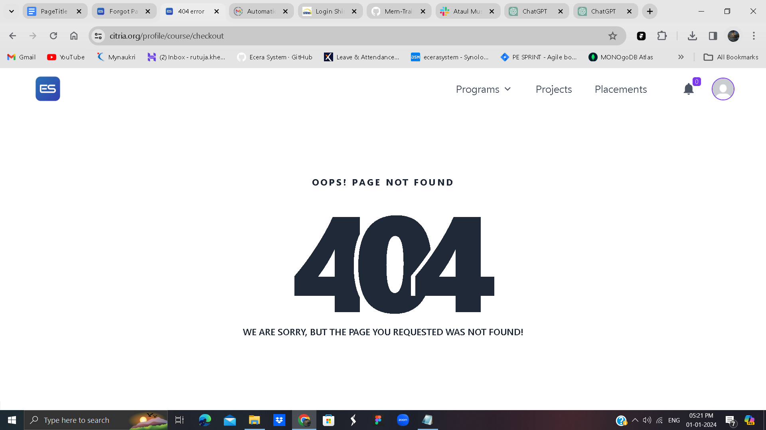

This code defines a React component named NotFound. It represents a custom 404 error page in a React application. Here's a breakdown of the code:

Imports:

import React from 'react';: Imports the React library.

import Header from '../Shared/Header/Header';: Imports the Header component from the specified location.

import PageTitle from '../Shared/PageTitle';: Imports the PageTitle component from the specified location.

Component Definition:

const NotFound = () => {: Defines a functional component named NotFound.

Component JSX Structure:

<PageTitle title="404 error" />: Uses the PageTitle component to set the title of the HTML document to "404 error". This is typically done for better SEO and user experience.

<Header />: Renders the Header component, assuming it contains the header content of the application.

The rest of the JSX structure represents the layout of the custom 404 error page. It includes a title, a large stylized "404" text, and a message apologizing for the not-found page.

Export Component:

export default NotFound;: Exports the NotFound component for use in other parts of the application.

This component is meant to be displayed when a user navigates to a page that doesn't exist, providing a visually appealing and informative 404 error page.